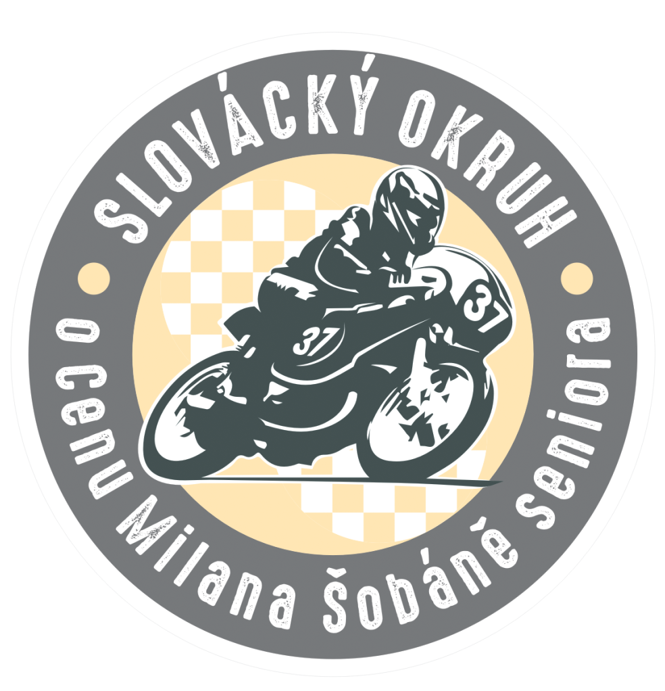

Special Provisions

XX. Year – Slovácký okruh

For the award of Milan Šobáň Sr.

AČR: 210/401

1/ Notice:
Motoklub Staré Město z.s. in cooperation with the town of Staré Město and Willi Race Team klub
in the Czech Republic is organizing a race SZM 210/401 Slovácký okruh, which will include: Open MČR on Natural Circuits in categories: 125 SP, 300SSP, Supermono, Supertwin, 400 SSP, Supersport 600,Superbike. Czech championship in categories: 125 GP/Moto3, Klasik Superbike, 250 Open, Klasik A do 175 ccm, Klasik A do 250 ccm, Klasik A do 350 ccm, Klasik B do 125 ccm, Klasik B do 250 ccm, Klasik B do 350 ccm, Klasik A do 500ccm, Klasik B do 500 ccm, Klasik A do 750 ccm, Klasik B do 750 ccm. Free JPHZM – sidecars.

The race will be organized on 4-5 May 2024 at the city circuit in the Staré Město.

2/ Secretariat of the organizer:
Motoklub Staré Město z.s., Velehradská 2230, 686 03 Staré Město
Delivery address: Motoklub Staré Město z.s., Velehradská 2230, 686 03 Staré Město
E-mail: slovackyokruh@seznam.cz

Telephone contacts:
Bc. Petr Chmelař, MBA, chairman of the club mobile: +420 732 471 534
Petr Neubauer, race secretary mobile: +420 605 540 757

3/ Organizer's address during the race

Ulice Východní, 686 03 Staré Město

Mgr. Martin Zábranský, Mayor of Staré Město mobile: +420 702 176 572
Petr Neubauer - race secretary mobile: +420 605 540 757
MUDr. Radomír Prchal mobile: +420 604 338 595

4/ Track:
The length of the circuit is 4200 m, track width 6-9 m, elevation 35 m, the circuit is a road circuit
with a uniform asphalt surface with 5 right and 4 left turns and one retarder. The race will be run clockwise. The pole position is located on the left side of the track. The start is on the wave of the flag and with the engine running for all categories.

5/ Regulations:
This event will be run in accordance with the Environmental, Medical and General Sporting
Regulations of the MS AČR., the Rules of Road Racing of the MS AČR and these Special Provisions.

6/ Officials:
Chairman of the JURY Jan Adamek
Sports Commissioner Michaela Kotíková
Sports Commissioner Bc. Filip Fanta
Race Director Tomáš Jenčovský
Race Secretary Petr Neubauer
Head of Technical Control Oldřich Prokop
Technical Commissioners Vladimír Brixí,Martin Šafka,Jaroslav Rolc,TBA
Timekeeping and results processing Vlastimil Lobiš
Chief race doctor MUDr. Radomír Prchal
Ecologist Otakar Kotík

7/ Categories and classes:
All races are open, riders with an MS AČR license for SZM can participate (except Dragster, Mini Moto and Scooter licenses) and riders with other FMN licenses. CAMS licence is not considered acceptable for the 2024 Slovácký okruh. Only riders who hold a license issued by MS AČR will count points for the Czech Klasik Championship. In the other announced categories, all participating drivers score points. Riders with another FMN license must present their approval for the to start. Drivers in the Klasik B category must have a white letter B in half size on the front bonnet.
Listed Classes:
Czech championship Klasik A do 175 ccm Open MČR on Natural Cir. 125 SP
Czech championship Klasik A do 250 ccm Open MČR on Natural Cir. 300SSP
Czech championship Klasik A do 350 ccm Open MČR on Natural Cir. 400 SSP
Czech championship Klasik B do 125 ccm Open MČR on Natural Cir. Supermono
Czech championship Klasik B do 250 ccm Open MČR on Natural Cir. Supertwin
Czech championship Klasik B do 350 ccm Open MČR on Natural Cir. Supersport 600
Czech championship Klasik A do 500ccm Open MČR on Natural Cir. Superbike
Czech championship Klasik B do 500 ccm Free JPHZM sidecar
Czech championship Klasik A do 750 ccm
Czech championship Klasik B do 750 ccm
Czech championship Klasik superbike open
Czech championship 250 Open
Czech championship 125 GP/Moto3

Machines taken into the Klasik race cannot start in the Open MČR and machines taken into the Open MČR cannot compete in the Klasik races.
Only motorcycles according to the Technical Regulations of MS AČR are allowed.

8/ Limit of the riders:
Practice 36 riders Race 34 riders
Sidecars 22 pairs Race 22 pairs

When the maximum capacity of the track is reached, riders with earlier payment of the entry fee have the priority to start.

9/ Entry forms and entry fee
Entries must be submitted by 24.4.2024 in writing to the specified delivery address, or by sending an e-mail to: prihlaskaSO@seznam.cz, attaching a scanned, duly filled in entry application form on the official organiser's form attached to this Special provision. The rider's start is confirmed in advance on the basis of a duly completed and timely - by post or e-mail - entry form. In case of exceeding the possible limit of starters, the date of receipt of the application or the time of its receipt will be decisive for its acceptance. The list of properly registered and accepted riders with assigned start numbers will be announced in advance on the website in the Riders section at: www.slovackyokruh.cz

Delivery address for sending applications:
Motoklub Staré Město z.s.
Velehradská 2230
686 03 Staré Město

Email for sending applications:
prihlaskaSO@seznam.cz

Entry fee:

Entry fee for advance payment to the account until 26.4.2024 24:00
Singe start in CZK – 3800Kč or Entry fee in EUR - 160Eur
Double start in CZK – 6000Kč or Entry fee in EUR - 250Eur
Triple start in CZK – 8000Kč or Entry fee in EUR - 330Eur

When making a non-cash payment, always include the names in the "Message to Recipient". According to the rules of the AČR only two categories of competitions are possible: in Czech championship and Open MČR + possibly other classes are possible in free categories: JPHZM.
----------------------------------------------
For transactions in CZK use the following account: 1401103005/2700, UniCredit Bank Czech Republic and Slovakia.
BIC: BACXCZPP / SWIFT: CZ27 2700 0000 0014 0110 3005

For transactions in EUR, please use the account: 1401103013/2700, UniCredit Bank Czech Republic and Slovakia
BIC: BACXCZPP / SWIFT: CZ05 2700 0000 0014 0110 3013

The last payment can be credited until 26.4.2024 24:00. After that, payment can only be made in cash at the formal acceptance. The funds will be refunded only after sending a written apology to the e-mail: prihlaskaSO@seznam.cz until 29.4.2024 at the latest. The rider can transfer the entry fee to a friend/acquaintance, but only after written submission and approval of the organizer and no later than 29.4.2024.

Entry fee on site in cash only!

Entry fee on the place:
Singe start in CZK – 4500Kč or Entry fee in EUR - 200Eur
Double start in CZK – 6500Kč or Entry fee in EUR - 270Eur
Triple start in CZK – 8500Kč or Entry fee in EUR - 350Eur

10/ Parking lot for racing machines, arrival
Parking lot for racing machines is located on Východní street, see. below for a plan of the Parking lot for racing machines (PLFRM). Entry to the PLFRM area will be allowed on Friday 3.5.2024 from 12.00 no earlier!
In the PLFRM riders and their escorts are obliged to follow the instructions of the organizers and must, according to the regulations, use under the motorcycles ecological mats! When entering the PLFRM during practice or race, the rider must choose the left track of the track! The PLFRM facilities have their limitations, the participants must take into consideration that if the PLFRM director asks the team to move personal vehicles or other resources that are not absolutely necessary for the team's operation to nearby parking lots, the teams must do so!! Any other vehicles accompanying the competitors cannot be parked at PLFRM!
In 2024, we have prepared a new option for you to reserve a place in the PLFRM. We see this as a step towards the satisfaction of all participants and the aim is to prevent spontaneous "banding for mates".
Each competitor will have a reserved space, which will be confirmed by e-mail by the head of the PLFRM - phone + 420 734 705 811.
When submitting your application, you will also select one of the sectors where you would like to stand during the races by emailing parkovisteSO@seznam.cz. Depending on availability, the PLFRM boss will confirm your reservation or offer you another place if the space you want is already occupied.
Sector 1-13 does not open until Friday at 12:00 and therefore it is possible to pitch your tent after this time. For riders who arrive earlier than Friday there is a space 14-24. However, it is also important to remember that this space is also used by local companies for supplies until 12:00 on Friday, so it is necessary to follow the instructions of the head of the PLFRM and respect road safety.
If anyone parks in a space reserved for another competitor they will be banned from that space by the PLFRM Chief.
We realise that we are running the booking system for the first time and it may have some shortcomings, so we hope for your tolerance.
Each sector is divided into approximately 10 spaces of 6x3m and this size must be respected within the booking. In case of starting in more than one category, the space can be changed by agreement with the PLFRM boss.
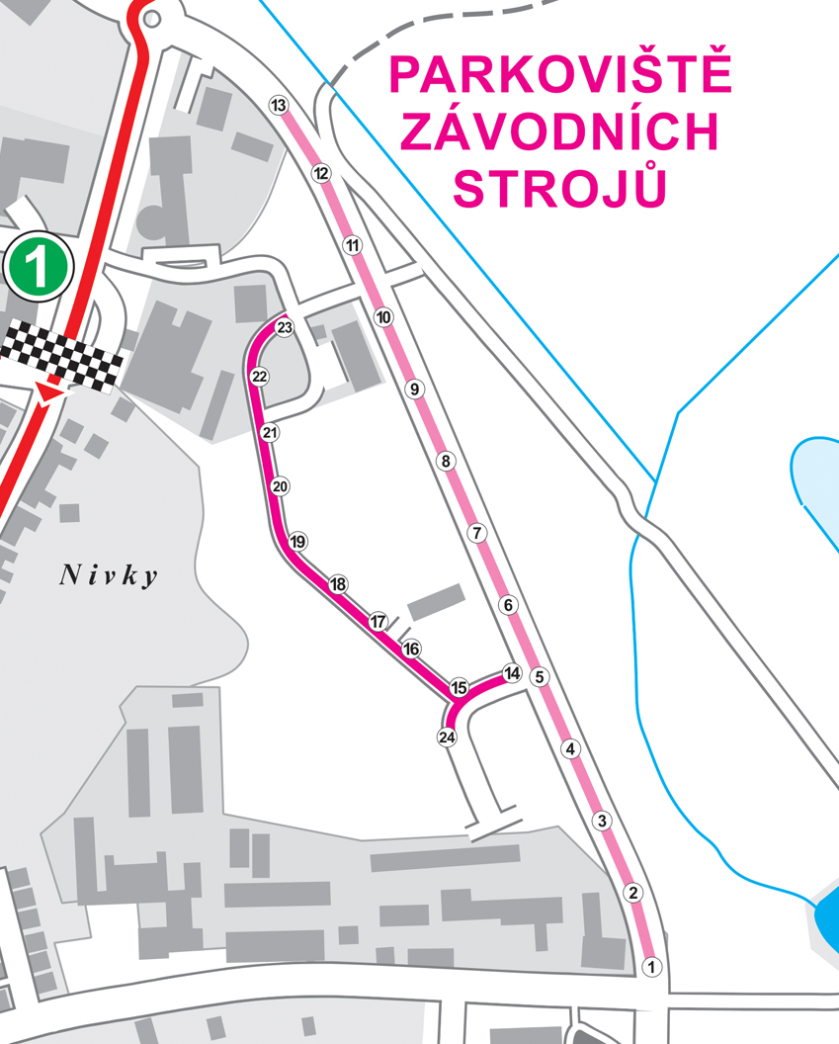

11/ Administrative and technical acceptance:
Administrative and technical acceptance will take place in the parking area of the racing machines and riders must appear in person at the administrative acceptance and present their license:

Friday 3.5.2024 from 13.00 to 20.00

Saturday 4.5.2024 from 07.30 to 08.30
Testing of motorcycles will be, by agreement with the commissioners, on Friday from 13.00 to 17.00.
Foreign riders shall present the permission to start issued by the FMN that issued the licence at the administrative acceptance. If an accident occurs during the event, a re-inspection of the race machine will be ordered. The 125 SP category machines will be weighed and five machines will be randomly selected for technical inspection after the race!

12/ Training + discussion
Discussion: on Friday 3.5.2024 20:00. at the information boards mandatory for all riders. The format of the debate will be in writing (the content of the debate will be in a document at the formal acceptance, which riders will sign at the end: I have read / I understand / I agree) - will be carried out by: race management
Riders who are riding on the Slovacký circuit for the first time must be marked with a reflective vest at least in both training sessions (the race is voluntary), which the organizer will lend to them at the formal acceptance against a refundable deposit of 500CZK/20Eur. The rider must complete at least 5 laps of the category during the reserved practice times! Attention, the first pass is not counted as a full lap! It is strictly forbidden to drive the racing machine on the track outside the official practice time.

Practice will take place on Saturday, May 4, 2024 as follows:

Class |  | I. Practice |  | II. Practice
klasik A (do r. 1972) do 175, do 250, do 350  klasik B (do r. 1978) do 125, do 250, do 350 |  | 8:00 - 8:20 |  | 13:00 - 13:20
125SP/125GP/Moto3/250 open/300SSP |  | 8:30 - 8:50 |  | 13:30 - 13:50
sidecar |  | 9:00 - 9:20 |  | 14:00 - 14:20
klasik SBK open + klasik do 500A/B + klasik do 750A/B |  | 9:30 - 9:50 |  | 14:30 - 14:50
supersport 600 |  | 10:00 - 10:20 |  | 15:00 - 15:20
supermono + 400 SSP |  | 10:30 - 10:50 |  | 15:30 - 15:50
supertwin |  | 11:00 - 11:20 |  | 16:00 - 16:20
superbike |  | 11:30 – 11:50 |  | 16:30 – 16:50
13/ Race - Sunday 5 May 2024
Class |  | exit from the parking lot of racing machines |  | start of the warm-up round |  | number of laps |  | length km
klasik A (do r. 1972) do 175, do 250, do 350 |  | 7:55 |  | 8:00 |  | 8 |  | 33,6
klasik B (do r. 1978) do 125, do 250, do 350 |  | 8:55 |  | 9:00 |  | 8 |  | 33,6
125SP/125GP/Moto3/250 open/300SSP |  | 9:55 |  | 10:00 |  | 8 |  | 33,6
klasik SBK open + klasik do 500A/B + klasik do 750A/B |  | 10:55 |  | 11:00 |  | 8 |  | 33,6
sidecar |  | 12:25 |  | 12:30 |  | 20min
supersport 600 |  | 13:25 |  | 13:30 |  | 10 |  | 42
supermono + do 400 SSP |  | 14:10 |  | 14:15 |  | 10 |  | 42
supertwin |  | 14:55 |  | 15:00 |  | 10 |  | 42
superbike |  | 15:40 |  | 15:45 |  | 10 |  | 42

14/ Awards

The first three riders of the classes of the morning block (Classics A and B 175, 250 +350 + 120GP + 250 Open + Classics Superbike + Classics500/750) will be decorated in the Sunday lunch break from approx. 11:15 to 12:00 in the parking lot of racing machines. The afternoon block of races will be decorated for the top three places separately after the last Sunday ride has been completed, again all categories will be decorated in turn at around 16:30.

15/ Protests
All protests must be submitted in accordance with the Disciplinary Regulations of the WS AČR and supported by a deposit of 5000,- CZK / 200 EUR.

16/ Fuel
Fuel must comply with the Technical Regulations for Road Racing for the classes entered. Nearest fuel station - Staré Město. The organizer does not provide fuel.

17/ Insurance
The organiser has insurance through the AČR, covering its own liability and the liability of all drivers, co-drivers, competitors and officials in the event of an accident caused to third parties during the event or official training, with Kooperativa, a. s. Vienna Insurance Group, through PLATINUM Consulting, s. r. o., č.p.s. TBA.
The organiser is obliged to arrange liability insurance for the participants of the event for damage caused to others by the operation of his vehicle during the sports event. Payment of this insurance is included in the entry fee. The organizer disclaims all liability for damage to the motorcycle, its accessories and parts, resulting from accidents, fire or other incidents. By issuing a consent to start, each FMN confirms that the rider /or co-driver/ is insured in accordance with the FIM requirement.

18/ Waiver of appeal against sports authorities
Notwithstanding the requirements of the General Sporting Regulations of the MS AČR, the participating drivers and co-drivers waive all rights of appeal against the organiser, its agents or intermediaries by arbitration, in court or in any other manner not provided for in the General Sporting Regulations of the MS AČR for all damages, for which they may be held liable as a result of any acts or omissions of the promoter, its officers, agents or intermediaries in the application of these provisions or any provisions that may be made in connection therewith or any causes that may arise from their operation.

19/ Concluding provisions
The Race Director is authorized to issue, as part of these Special Provisions, "Implementing Provisions" that will address any changes for the organized event. The Organiser reserves the right to cancel or postpone the event in the event of an emergency, and Force Majeure shall also relieve the Organiser of the obligation to honour its commitments.
The organizer warns in advance of the possibility of checking riders for prohibited substances and alcohol during the sporting event and immediately before the ride by a person authorized by the organizer (does not have to be an employee of the Police of the Czech Republic). For damages caused to the property of the city, other riders, etc. in the event of a positive finding of alcohol or other addictive substances in the body is not covered by the insurance of the race and the culprit of such an incident will bear the consequences in legal proceedings under the legislation of the Czech Republic.

20/ Circuit preparation (does not apply to foreign riders)
The organizer reserves the right to restrict participation in the races to riders residing 25km from Staré Město, who will not have completed at least 60% of the brigade hours will have to pay the entry fee. It is possible to use a replacement for your personal participation, the number of hours is recorded according to the physical presence of the Motoclub President and can be consulted at any time.

21/ Transponders
If measurements are to be made on the company by means of transponders (boxes), the rider will receive the box at the administrative acceptance or immediately afterwards for signature.
In this case, the rider is obliged to purchase, if he does not already have one, a holder for the box at a cost of 150,- CZK. / EUR 6,-
If the box is lost and not handed over after the competition, the rider is obliged to pay a sum of 8.000,- CZK / 300,- EUR
If he fails to do so, his licence will be withheld until this amount is paid.
The jury chairman is obliged to send the withheld licence together with the materials from the event to the MS AČR secretariat within 48 hours.

22/ Calm at night
The organizers ask all participants (not only riders, but also their teams and accompanying persons) of the Slovácký circuit to observe the night calm. The night calm is set by law from 22:00 to 7:00, the organizers will be tolerant until 23:00. After that, please try to respect people who really want to race and need to rest.

23/ Environmental Directive
All riders are obliged to comply with the Environmental Regulations of the MS AČR. The area for pouring out oils and other environmentally harmful substances and substrates is set up next to the technical acceptance station for riders. It is forbidden to discharge waste water from cars in the parking lot of the racing machines outside the places equipped with appropriate waste water facilities. Violation of the prohibition of discharging such substances in other areas is fined with the amount of CZK 5 000,-. The rider is obliged to purchase and use a catching "ABSORPTION MATTRESS" with a minimum size of 100x160 cm at his own expense. This mat must always be placed under the motorcycle in the parking lot of the racing machines, in case of any manipulation (repairs, lubrication, cleaning of the motorcycle, etc.). The mats must be of the ECOSORB, REOMAT, etc. type. In no case may they be replaced by e.g. plastic foil, carpet or other residual material. Failure to use "ABSORPTION MATS" may be fined CZK 3,000.

In Uherské Hradiště

Tomáš Jenčovský v. r. Petr Neubauer v. r.

……………………………. …………………………….
Tomáš Jenčovský, Race Director Petr Neubauer, Race Secretary

Annex: application form

Parking map for racing machines (service zone)
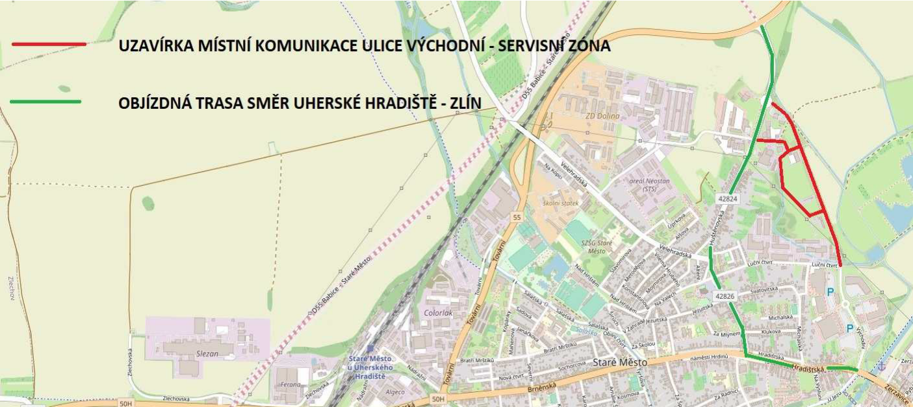
Map of the racing circuit

